VBA Homework-Stock Analysis

Screenshots of the different years- there is 1 per page so I could try and show you as many as possible while making it readable.

2014 Tab

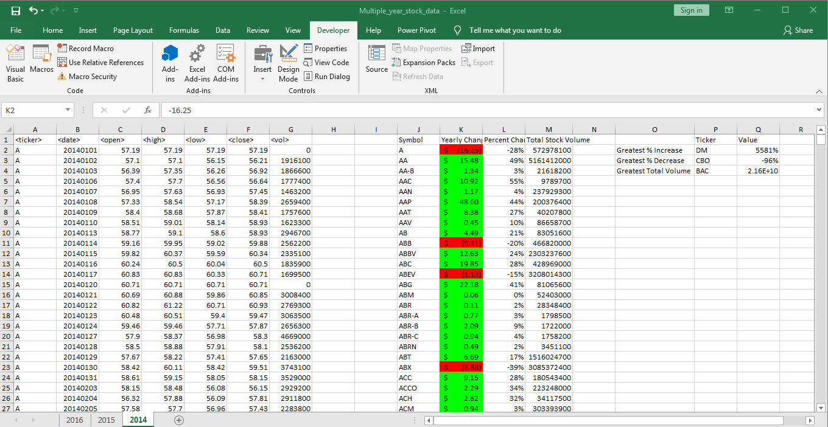

2015 Tab

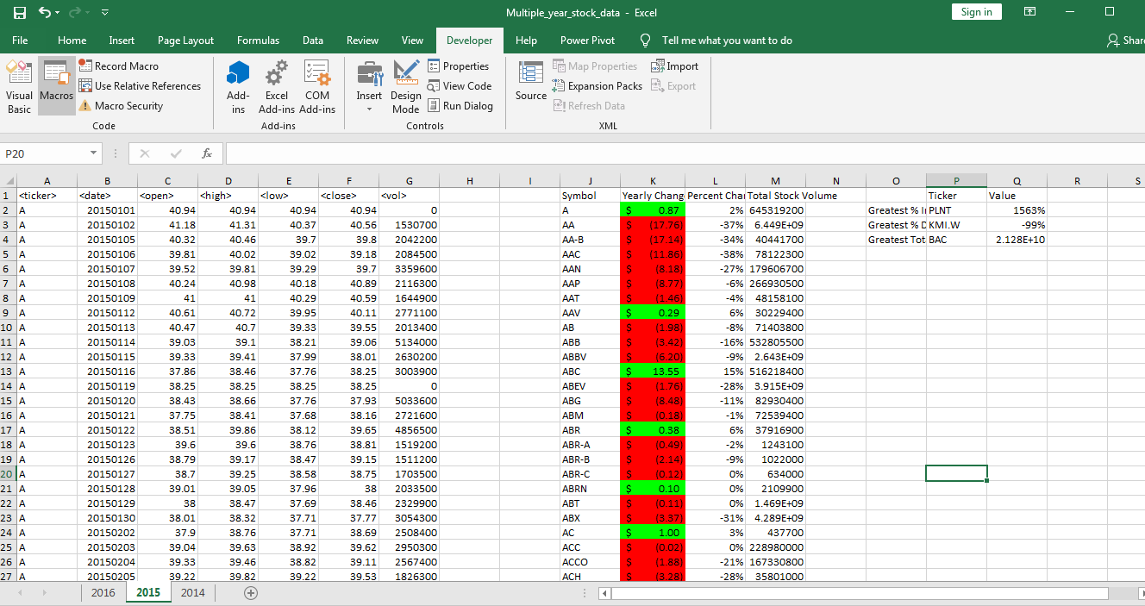

2016 Tab

